The health domain is shaped by many standards and models that guide the design of databases and the implementation of systems. They are applied in diverse contexts, from hospital records to research infrastructures. To enable effective data reuse, the data within these systems often needs to be exchanged, compared, and integrated, i.e., the data must be interoperable (fulfilling the “I” in FAIR). But achieving this is technically complex, time-consuming, and prone to errors when relying on case-by-case mappings between standards. In the past, several initiatives have sought to address this challenge, and while they brought valuable contributions, some unintentionally added to the creation of a ‘standard #15,’ resulting in another model in an already crowded landscape.
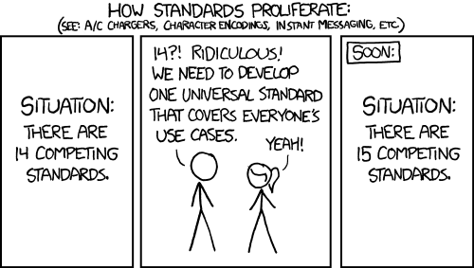
xkcd Comic #927. Source: https://xkcd.com/927/
Important efforts such as FHIR, OpenEHR, SNOMED CT, OMOP, and convergence initiatives between them remain crucial endeavors for interoperability, and our work builds directly on them while taking a distinct perspective. The Health-RI Semantic Interoperability Initiative addresses this challenge by developing a unifying upper-level ontology that defines the precise meaning of key concepts already present in widely used standards such as FHIR, OMOP, and OpenEHR. This ontology serves as a shared reference point, allowing existing standards to map their concepts to it. Through this mapping, the intended meanings become clear and explicit to anyone who needs to interoperate with them.
We do not intend to replace the standards and models already in use, into which research groups and institutions have invested significant effort and resources. Instead, our approach replaces the need for multiple pairwise mappings between those standards with a single, reusable mapping to our ontology. This makes the Health-RI Semantic Interoperability Initiative non-intrusive: the ontology complements existing efforts and provides the semantic backbone that supports their interoperability. We know this is complex and ambitious work, but once a mapping is created it can be applied consistently across different projects and contexts. By relying on solid theoretical foundations and state-of-the-art technologies, and by working together as a community, we are confident that we can turn this work into a practical means for achieving semantic interoperability.
At this early stage, as we continue to explore alternatives and collaborations, we are already receiving valuable support and feedback from academics and professionals across the nodes, as well as from the Zorginstituut Nederland, the Oncology CDM Group, and colleagues involved in OpenEHR and FHIR. Their perspectives are helping us shape the work and ensure it stays aligned with the broader community.
We invite you to explore the resources we are making available, including our ontology and mapping sets, which are openly published and continuously improved (see the initiative at https://w3id.org/health-ri/semantic-interoperability). We also welcome direct engagement, whether through sharing feedback, proposing new mappings, or discussing use cases and potential applications with us. After all, semantic interoperability can only be achieved through the community: initiatives earn trust only when they are built openly and collaboratively. Together, we can ensure this effort translates into real, lasting improvements in how health data is shared and reused.

